, Integrated Marketing Communications " ... Recognizes The Value Of a comprehensive plan that evaluates the strategic roles of a variety of communication disciplines advertising, public relations, personal selling, and sales promotion and combines them to provide clarity, consistency, and maximum communication impact
Read more: http://www.businessdictionary.com/definition/integrated-marketing-communications-IMC.html#ixzz3SxRupjjR
Public relations is communicating your organization’s messages at the right time and in the right place to the right audience. With the proliferation of tools and technologies, we can measure the value of those efforts and how they align with a business’ overall mission.
PR focuses on building good relations with the company’s various publics by obtaining favorable publicity, building a good corporate image, and handling crisis management issues. Today, a good PR firm must be experts in use of social media.
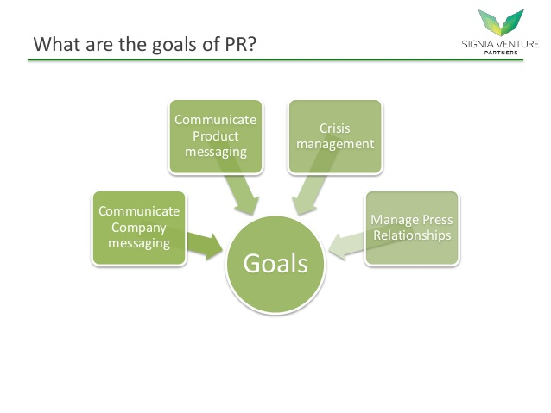
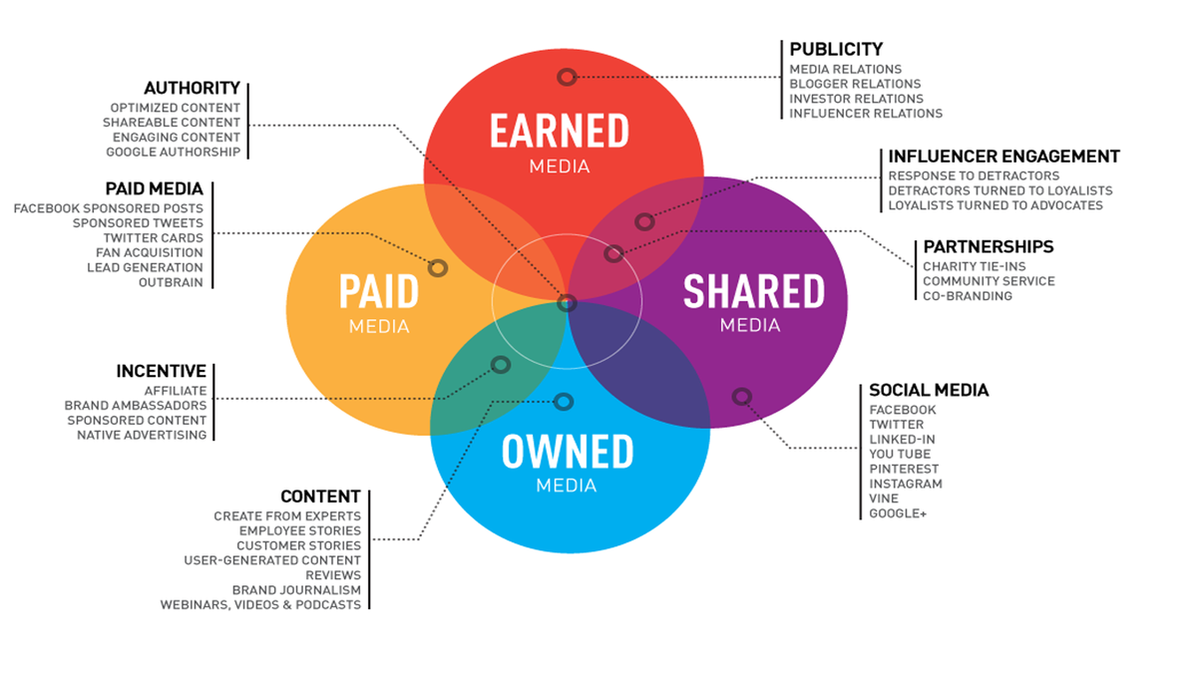

THANK YOU MOM

BACKGROUND
Procter & Gamble had long been committed to supporting the efforts of U.S. Olympic athletes, but was looking for a way to elevate its support of the Olympic movement to new heights. In late 2009, P&G became an Official Sponsor of the U.S. Olympic Committee (USOC).
The company’s previous Olympic-themed campaigns, in support of national governing bodies and Olympians, had centered on individual brands and scale executions. Consumers were more aware of iconic product brands like Tide and Pampers than of the global company behind the brands.
With the 2010 Olympic Winter Games in Vancouver on the horizon, a major marketing opportunity lay ahead for the world’s leading consumer products company.

THE CAMPAIGN
In support of the 2010 Olympic Winter Games, P&G announced it would mount the first U.S. corporate marketing campaign in its history. Taylor was challenged with developing a marketing communications program to support the ‘Thank You Mom’ advertising campaign.
Taylor and P&G worked closely with the USOC to conduct research that uncovered the unique sacrifices made by the mothers of Olympic athletes. A key consumer insight that emerged was that many of these moms, after years of sacrifice, could not even afford to attend the Games to see their child compete. This resonated strongly with moms who participated in Taylor-initiated focus groups.
This insight inspired the extension of ‘Thank You Mom’ into a fully-integrated campaign supported by a ground-breaking initiative whereby P&G covered the expenses for the mom of every U.S. Olympic and Paralympic athlete to ensure they would be in Vancouver with their children.
Taylor then helped P&G engage with consumers throughout the Vancouver Games with a multi-channel public relations campaign that leveraged key components including the P&G Family Home and several individual athlete sponsorships.

THE RESULTS
The public relations efforts alone achieved more than 2,800 total media placements, generating 2.6 billion impressions and attracted glowing coverage from The Today Show,The New York Times and other top national media. One of the most widely-acclaimed campaigns of 2010, the fully integrated ‘Thank You Mom’ campaign resulted in nearly $100 million in incremental sales for P&G and the company’s highest aggregate U.S. market share for the fiscal year in the JFM quarter.

